Sensors and Actuators B: Chemical
A versatile lab-on-a-chip tool for modeling biological barriers
Fruzsina R. Walter#, Sándor Valkai#, András Kincses, András Petneházi, Tamás Czeller, Szilvia Veszelka, Pál Ormos, Mária A. Deli*, András Dér*
Institute of Biophysics, Biological Research Centre, Hungarian Academy of Sciences, Temesvári krt. 62, H-6726, Szeged, Hungary
# authors contributed equally to this manuscript

* Corresponding authors:
András Dér
E-mail: der.andras@brc.mta.hu
and
Mária A. Deli
E-mail: deli.maria@brc.mta.hu

Results
Evaluation of permeability data vs. molecular size
Three permeability marker molecules with different size were used: fluorescein (376 Da, d = 1 nm, [S1]), FITC-dextran (4.4 kDa, d = 2.8 nm; [S1]), albumin (67 kDa, d = 7 nm; [S2]). The transfer of fluorescein, the smallest molecule, was the highest and that of albumin, the biggest molecule, was the lowest across all four barrier models (see Fig. S2). These results are in agreement with the data of Fu et al. [S1]. They demonstrated that dextran-20 kDa, -40 kDa, and -70 kDa have a large difference in molecular weight but their in vivo blood-brain barrier permeability only differs by less than 35 %, suggesting that these barriers are selective to large marker molecules and less selective to small solutes, like fluorescein and FITC-dextran 4.4 kDa, which have higher permeability. Those models, Caco-2 and primary brain endothelial cells which have the highest resistance, have the lowest permeability and the A549 and D3 models which present low resistance show high permeability for the markers.

Establishment of the device in a laboratory environment
Performing chip experiments in several parallels was feasible, as demonstrated by the photos of our work stage showing the system level of the experiments (Fig. S3). A dedicated space was used for the chip studies, where the laminar box, the incubator and the phase contrast microscope were very close to each other (Fig. S3A). Our peristaltic pump can accommodate up to 8 silicon tubes, through which the flow can be maintained in the same number of chips, simultaneously (Fig. S3B,C). The tubes and the electric wires for the TEER measurements can operate even if the door of the incubator is closed, allowing a full computer control of this part of the experiments. The chips are removed from the incubator only for microscopic observation, but this procedure is also performed on site (Fig. S3D).

Evaluation of the transmission spectra of golden or ITO electrodes
The transmission spectra of the ITO and gold electrodes were recorded by a spectrophotometer (Unicam UV4) from 400 to 700 nm. As it is shown, even the transmission of the gold electrodes exceeded 50% (Fig. S4), allowing visual monitoring of the full barrier surface by a phase contrast microscope (see Figs. 4-7. in the paper).

References
[S1] L. Shi, M. Zeng, Y. Sun and B.M. Fu, J Biomech Eng, 136, 031005 (2014)
[S2] A. Tojo and S. Kinugasa, Int J Nephrol, 2012, 481520 (2012)
Fig. S1

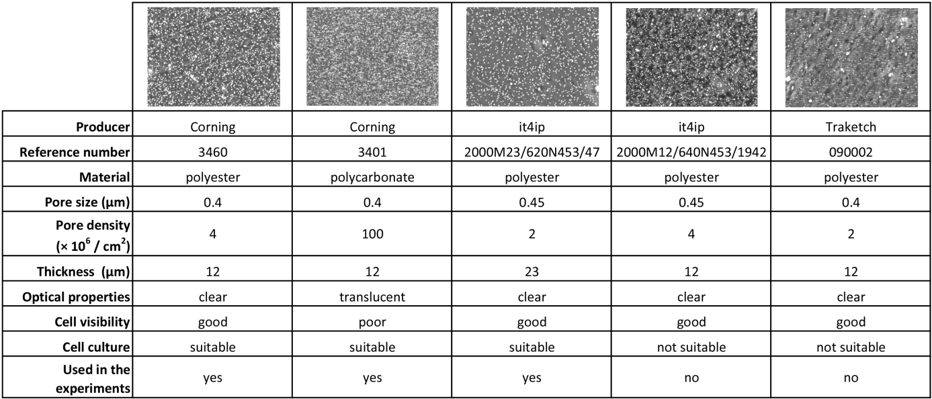

Fig. S1 During the biochip fabrication process several cell culture membrane types were tested (Fig S1). The membranes used in Transwell inserts from the distributor Corning are not commercially available (Fig S1, first and second columns). Due to the length of the channel (37 mm) excision of the membrane from Transwell inserts (12 mm) is not feasible. As alternative solution membranes from it4ip and Traketch were also tested. Only one membrane from it4ip with a double membrane thickness proved to be suitable for cell culture (Fig S1, third column). Unfortunately porous membranes with similar thickness to Transwell were not suitable for cell culture (Fig S1, last two columns).

Fig. S2
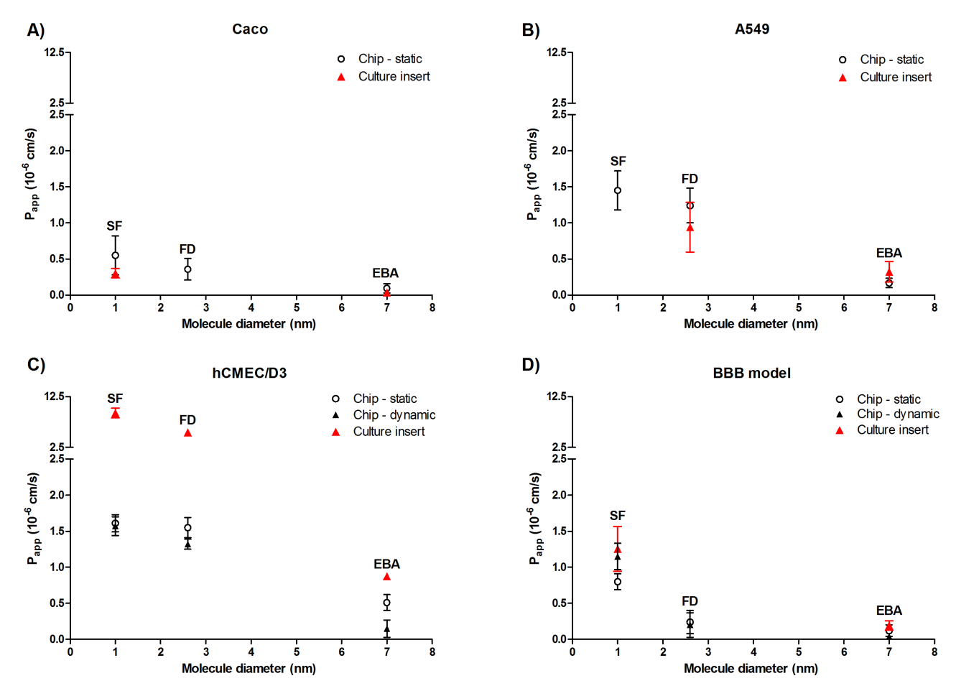

Fig. S2 Permeability coefficient values for the four barrier cell culture models in the chip under static and dynamic conditions and on cell culture inserts are indicated. (A) Caco intestinal epithelial cell line data, (B) A549 lung epithelial cell line data, (C) hCMEC/D3 brain endothelial cell line data, (D) triple co-culture blood-brain barrier (BBB) model data. Values are plotted versus the molecule diameters of fluorescein (SF, 376 Da, d = 1 nm), FITC-dextran (FD, 4.4 kDa, d = 2.8 nm) and albumin (EBA, 67 kDa, d = 7 nm).

Fig. S3

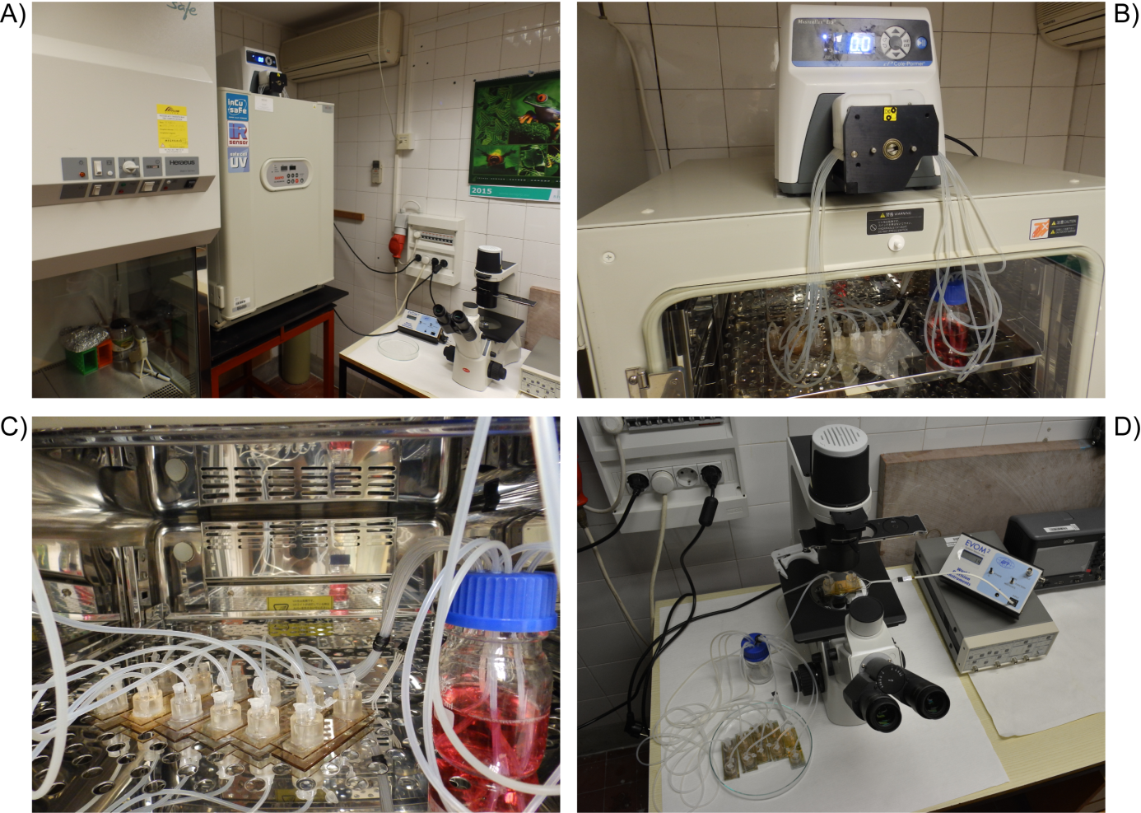

Fig. S3 Establishment of the device in a laboratory environment is shown. On our working stage the laminar box, the incubator and the phase contrast microscope were very close to each other (Fig. S3A). Arrangement of the peristaltic pump, the incubator, the reservoir and the biochips (Fig. S3B,C). Microscopic observation and resistance measurement (Fig. S3D).

Fig. S4
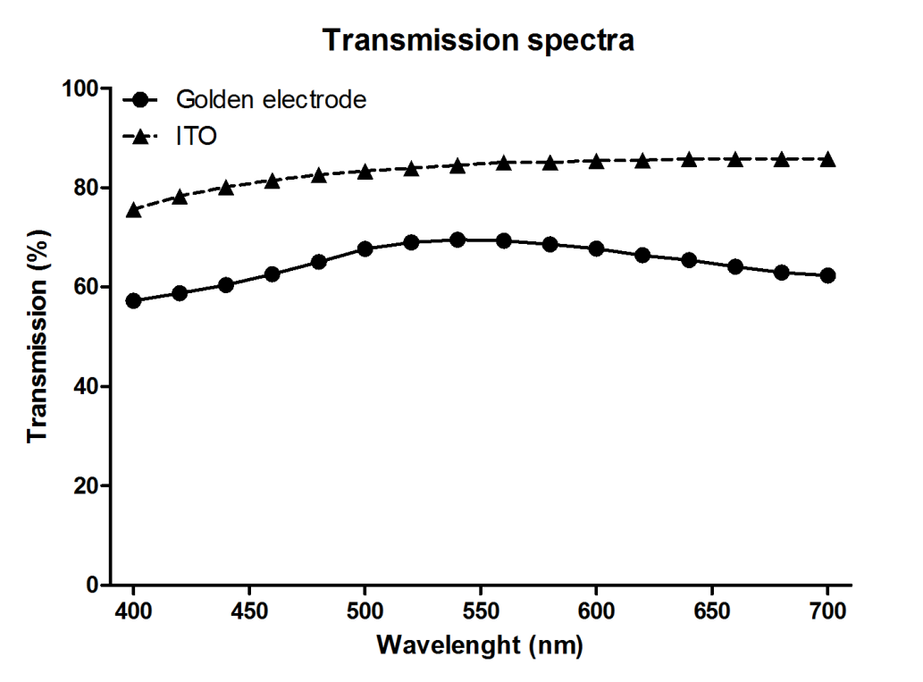

Fig. S4 Transmission spectra of the ITO and gold electrodes recorded by a spectrophotometer from 400 to 700 nm.

